Practice Problems: Hypothesis Testing for One Population Mean and Proportion
Q1. In hypothesis testing for a population mean:
a) When do we use a t-test instead of a z-test?
b) What happens to the margin of error when sample size increases?
c) What does a p-value represent?

Q2. A sample of n = 25 students has:
- mean = 72
- standard deviation = 10
Test at α = 0.05 whether the true mean is 75.
Tasks:
- State hypotheses
- Compute test statistic
- Write the formal statement of probability for p-value and the filled in R function.
- use: $t_{\left\{0.975,24\right\}} = 2.0639$ to make a decision
- Write a conclusion

Q3. A nutritionist claims the average calorie intake in the target population is less than 2000.
Sample:
- n = 64
- mean = 1950
- sd = 180
Test at α = 0.01
qnorm(0.95) = 1.644854 qnorm(0.975) = 1.959964 qnorm(0.01) = -2.326348 qnorm(0.005) = -2.57582

Q4. A sample of delivery times (minutes):
12, 15, 14, 10, 13, 16, 11, 14, 15, 13
By using the provided RStudio output, test the hypothesis at a 5% significance level whether the mean delivery time is more than 13 minutes.
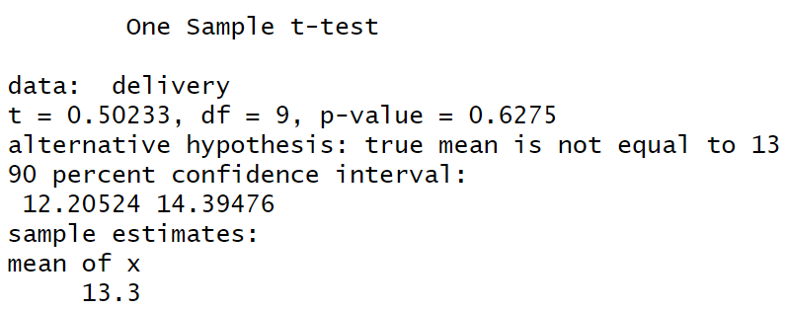

Q5. A survey records responses (1 = success, 0 = failure):
1, 0, 1, 1, 0, 1, 1, 1, 0, 1, 1, 0 ,1,1,0,1,0,1,1, 0, 0, 0, 1, 0, 0
Test if the true proportion of success is greater than 0.5 at α = 0.05.

Q6. A two- tailed test of population mean yields:
- p-value = 0.08
- α = 0.05
a) What is the decision?
b) Would the 95% confidence interval contain the null value? Explain.

Q7. A hypothesis test produces a p-value = 0.03.
Which of the following statements are correct?
a) There is a 3% probability that the null hypothesis is true
b) There is a 3% probability of observing data this extreme (or more) if the null is true
c) The alternative hypothesis is true with probability 97%
d) The result is statistically significant at α = 0.05
Select all that apply and explain why the others are incorrect.

Q8. A test gives p-value = 0.07.
What happens to your conclusion if:
a) α = 0.05
b) α = 0.10
Explain why the conclusion changes (or doesn’t) even though the data is the same.

Q9. Two studies test the same hypothesis:
- Study A: p-value = 0.049
- Study B: p-value = 0.001
Both use α = 0.05.
a) Do both reject the null hypothesis?
b) Which study provides stronger evidence against the null?
c) Why is it misleading to treat both results as “equally significant”?

Q10. A researcher fails to reject the null hypothesis (p-value = 0.12).
Which statements are correct?
a) The null hypothesis is true
b) There is not enough evidence against the null
c) The sample size might be too small
d) The effect definitely does not exist
Select all that apply and justify.

Q11. A 95% confidence interval for a mean is:
(10.2, 14.8)
You are testing:
H₀: μ = 10
HA: μ $≠$ 10
Will the p-value be less than or greater than 0.05?

Normality Test
When constructing a confidence interval for $μ$ or testing hypothesis for one or two population means, we are always assuming that the underlying distribution is normal, that is our sample is taken from a population that is approximately normally distributed.
This assumption needs to be tested for. If we have no reason to believe the normal distribution is a good fit for the sample data, we need to use non-parametric statistical methods, for example, instead of paired sample t-test, we will need to use Wilcoxon signed-rank test as a non-parametric alternative.
To test the normality assumption, we will visit two methods: one graphic and one numeric method.

Graphic Method:

Visual assessment of normality is usually done by constructing a Q-Q plot.
a Q–Q plot (quantile–quantile plot) is a probability plot, a graphical method for comparing two probability distributions by plotting their quantiles against each other.
If the two distributions being compared are similar, the points in the Q–Q plot will approximately lie on the identity line y = x.
Examples of non-normal versus normal data:
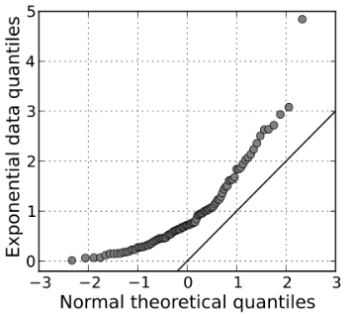 | 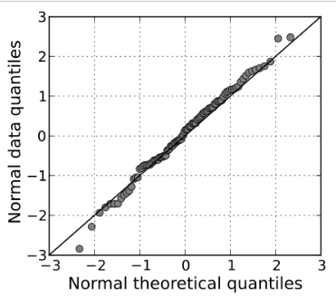

To make a QQ-plot in Excel:
- Sort data from small to large
To make QQ-plot in R:
- Load and name data as needed
- Run the following code, be sure to replace “Data” with the correct name.

qqnorm(Data, main = "Normal Q-Q Plot", xlab = "Theoretical Quantiles", ylab = "Sample Quantiles",
plot.it = TRUE, datax = FALSE)
qqline(Data, datax = FALSE, distribution = qnorm, probs = c(0.25, 0.75), qtype = 7)

Numeric Method
Among all numeric methods of testing for normality, the Shapiro Wilks Test has the most power.
The Shapiro–Wilk test tests the null hypothesis that a sample $x_{1}, ..., x_{n}$ came from a normally distributed population.
The null hypothesis of this test is that the population is normally distributed. Thus, if the p value is less than the chosen alpha level, then the null hypothesis is rejected and there is evidence that the data tested are not normally distributed.
To perform Shapiro Wilks test in R:
shapiro.test(Data)

$H_{o}:$Data comes from a normal distribution
$H_{A}:$ Data does not come from a normal distribution.
We tested Delivery time data for normal distribution using Shapiro Wilk test:
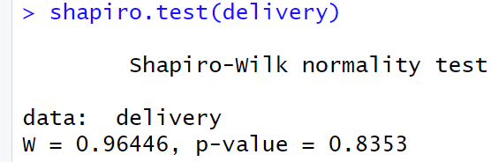
Decision: p-value is much larger that alpha, therefore we fail to reject H0
Conclusion: the underlying distribution of Delivery Time sample is normal.

https://en.wikipedia.org/wiki/Q%E2%80%93Q_plot

